User Manual

How to use the Bioethics Case Creation Software

David Wauchope

Devon Rimmington

Faye Teeuwen

Matthew Smith

Contents

List of Figures 2

Using Twine 3

What is Twine? 3

Twine Editor 3

Cases 3

Passages 3

Adding a new case 4

Editing a Passage 5

Formatting Text in a Passage 6

Adding a Passage 7

Linking passages to other passages 8

Deleting a passage 8

Playing a case 9

Publishing a case 10

Restoring a Case from File 10

List of Figures

Figure 1: Creating a case 4

Figure 2: Editing a passage 5

Figure 3: Adding a passage in the case editing screen 7

Figure 4: Linking passages together 8

Figure 5: Deleting a passage 8

Figure 6: Playing a case 9

Figure 7: Case Options 10

Using Twine

What is Twine?

Twine is a flowchart-styled information storage system, that allows pieces of text to be linked to any other piece of text inside the Twine stories database. Twine is an open source project and hence has more features than can be covered in this documentation. It is recommended that users of the software visit the wiki at [http://twinery.org/wiki/twine2:guide](http://twinery.org/wiki/twine2:guide%20) for screencasts and detailed documentation. Furthermore, it is likely that the editor will be using the Harlowe story format, for documentation on the Harlowe format visit <http://twine2.neocities.org/>.

Twine Editor

The Twine editor is software that allows a user to create and edit stories and then publish or save them. It features two distinct interfaces: the main menu to which create cases, and the case editing interface.

Cases

Cases (stories) are individual entities that editors create so that users can traverse through the content. They can be saved as files onto a local machine or stored on a server so that users can access them. These cases contain the information that users will play, and are created through the Twine Editor.

Passages

Cases are composed of passages. Passages are discrete screens of information that are displayed to the viewer. Passages are created by the editor through a text box and can connect to other passages. It is this chain of passages that creates an interactive story for players to go through.

Adding a new case

In the Twine editor main interface shown in Figure 1, you will see a list of stories/cases that exist in the Twine database, as well as some tools in the sidebar. To create a new story, search for the green “+Story” button located in the upper right hand side. You will be prompted to enter a name for the story, and then will be directed to an empty story page with a single passage.

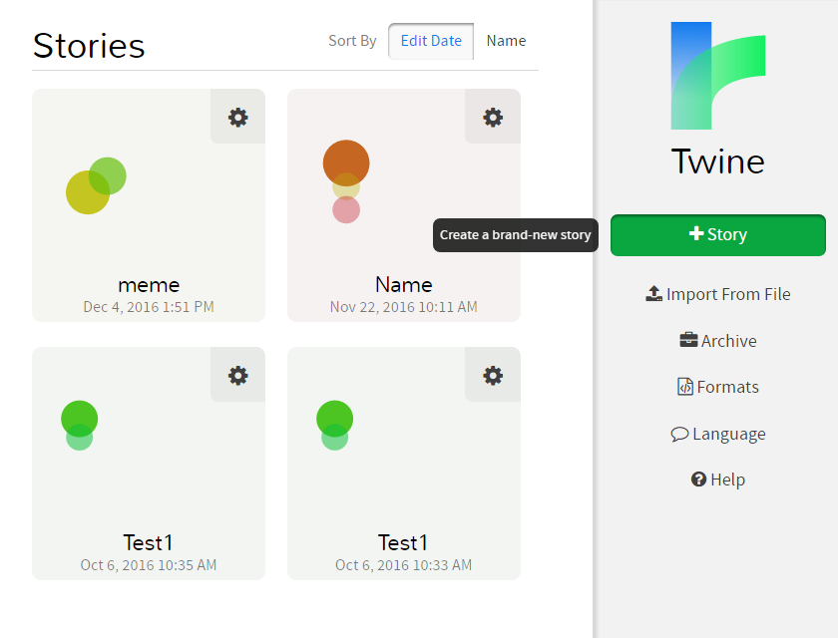

Figure : Creating a case

Editing a Passage

To edit the cell, double click on it to edit it resulting in the display of an editable text box as shown in Figure 2.

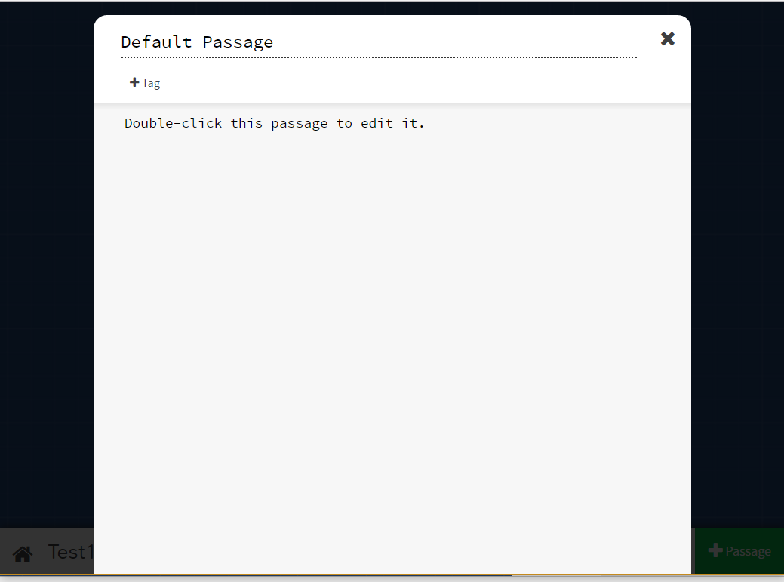

Figure : Editing a passage

Formatting Text in a Passage

Formatting can be integrated into the text included in the passage of any of the cells in the Twine flow layout. One can either use HTML or markdown: in either case, words or characters can be surrounded with syntactical cues to indicate to the Twine system that an area of text is to be represented by a specified effect. Syntax is included as shown below in Table 1. (Source: <http://twine2.neocities.org/#markup_style> ).

|  |  |  |  |
| --- | --- | --- | --- |
| **Styling** | **Markup code** | **Result** | **HTML produced** |
| Italics | //text// | *text* | <i>text</i> |
| Boldface | ''text'' | **text** | <b>text</b> |
| Deleted/ spoiler text | ~~text~~ | text | <del>text</del> |
| Emphasis | *text* | *text* | <em>text</em> |
| Strong emphasis | **text** | **text** | <strong>text</strong> |
| List | * item 1  * item 2  ** child item | * item 1 * item 2   + child item | <ul>  <li>item 1</li>  <li>item 2</li>  <ul>  <li>child item</li>  </ul>  </ul> |
| Ordered List | 0. item 1  0. item 2  0.0. indented item | 1. item 1  2. item 2  1. indented item | <ol>  <li>item 1</li>  <li>item 2</li>  <ol>  <li>indented item</li>  </ol>  </ol> |
| Headings | #Heading 1  ###Heading 3  #####Heading 5 | **Heading 1**  **Heading 3**  ***Heading 5*** | <h1>Heading 1</h1>  <h3>Heading 3</h3>  <h5>Heading 5</h5> |

Table 1: Basic formatting of text

More formatting options can be found in the documentation at <http://twine2.neocities.org/>

Adding a Passage

Additional passages can be added by clicking the green “+Passage” button in the bottom right of the Twine interface as shown in Figure 3.

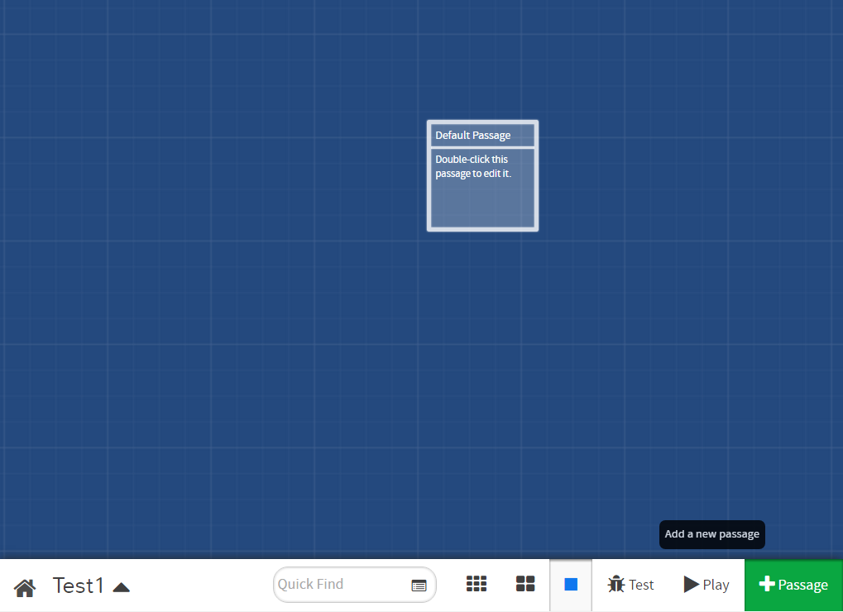

Figure : Adding a passage in the case editing screen

.

Linking passages to other passages

To create a link inside the text of one passage to another passage, links are written as follows:   
[[*Text to display*|*Passage to jump to*]]  
In this example and as can be seen in Figure 4, the displayed text is the text of what will be shown inside the passage, and the title of passage is the name of the passage that the link will direct to. These two syntactical items are surrounded by double block brackets, and separated by ‘ | ’.

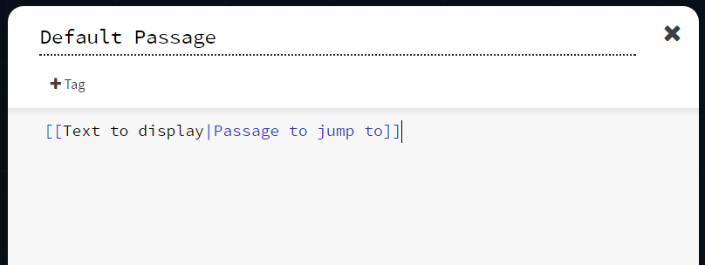

Figure : Linking passages together

Deleting a passage

A passage can be removed simply by clicking the passage in the Twine interface, and selecting the trashcan icon beneath it as shown in Figure 5.

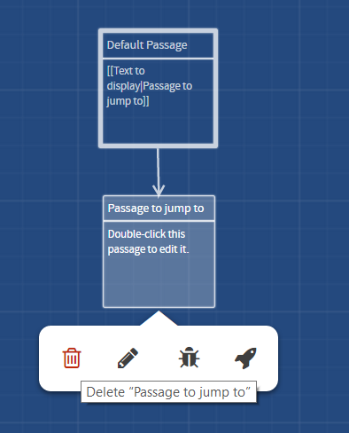

Figure 5: Deleting a passage

Playing a case

While in a case, one can press the “Play” button to simulate navigating through the case as a user as shown in Figure 6. Cases can be read in a nonlinear fashion that is similar to a webpage. Links included inside case passages can point to other passages or even websites on the internet. When clicking on one of these links, the user will be directed to a new passage, each with its own links.

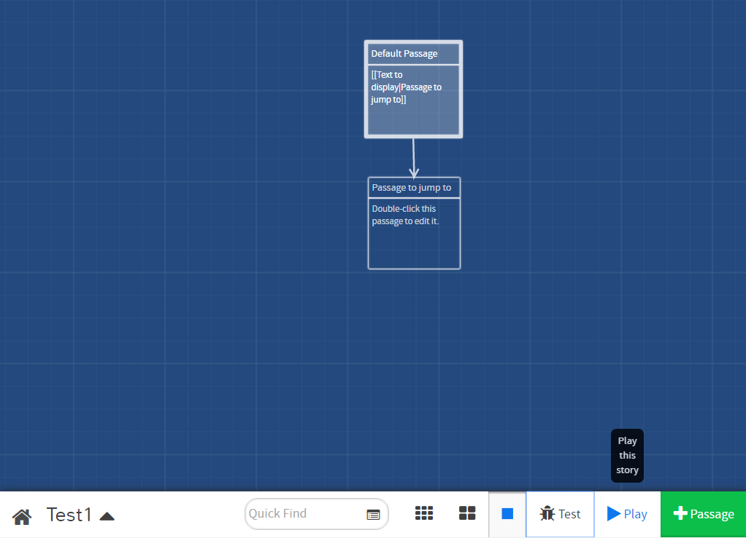

Figure : Playing a case

Publishing a case

Cases are by default stored into one’s browser cache, however if one clears one’s cache, the cases will be lost. It is recommended to publish a case to file or click the archive button to save all cases into a file on the computer.

On the story’s main menu seen in Figure 6, where one can see a list of all the created cases, click on the gear icon in the top right of the case which one wishes to publish.

Click the publish to file button to save it to a local computer. Alternatively, click the publish to server button to save it onto the server for public viewing.

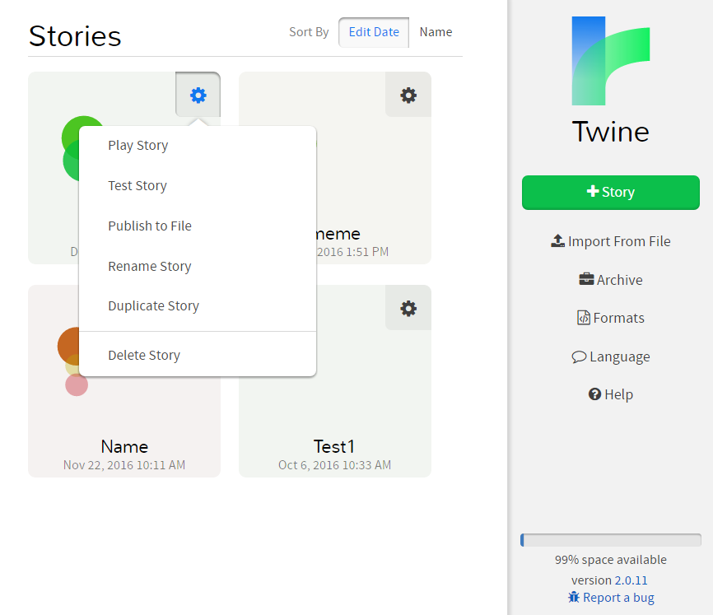

Figure : Case Options

Restoring a Case from File

To restore a saved case for further editing, press the “Import From File” button and select the file in the file browser that appears.